OCA Learn

How do I submit an assignment through OCA Learn?
To submit an assignment, follow the step-by-step guide below:
- Once signed into OCA Learn, navigate to 'My Courses' located in the upper-right corner and select your course from the list.
- Select the project number that contains the assignment you wish to submit from the 'Contents' menu located on the left e.g. Project 1 will usually contain the activity for Assignment 1.
- Navigate to the assignment activity - generally located at the end of the project - and click on the activity title to view the assignment submission page.
You can now select the 'Add submission' button, as shown in the screenshot below.
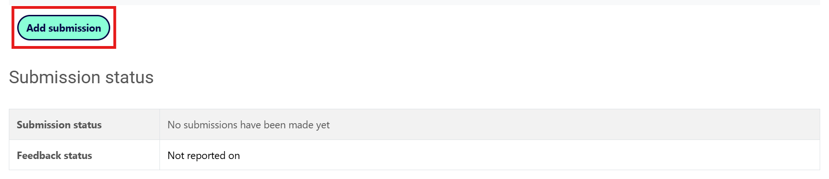

- Files saved on your device, or your OCA GDrive, can be submitted under the 'File submissions' heading. You can either select the 'Add...' icon, as shown in the screenshot below, or drag and drop files from your device folder(s) onto the 'You can drag and drop files here to add them' section.
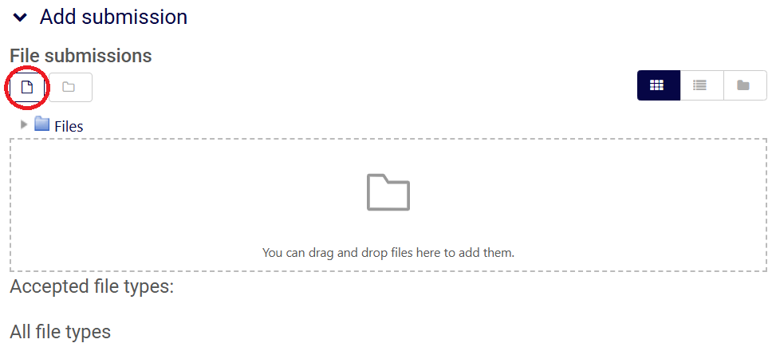
- You must ensure that you include a link to your OCA Spaces learning log. If you don't know the web address, first navigate to your learning log and copy the URL from the address bar at the top of your web browser (the format will always be spaces.oca.ac.uk/YOURSITENAME).
- You can now create a hyperlink by selecting the 'Link' icon as circled in the screenshot below and pasting the URL into the 'Enter a URL' field.
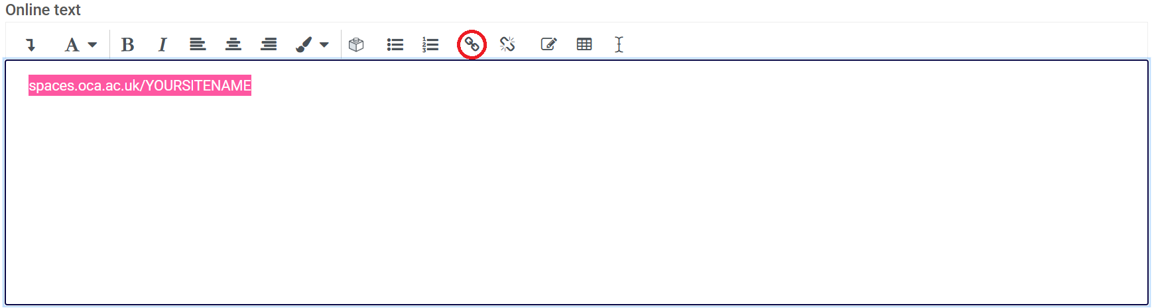
- Once you have provided a link to your learning log and uploaded any additional files, select 'Save changes'. On the next page, you'll then need to confirm your submission by selecting 'Submit assignment'; failure to follow this final step will result in your submission being saved as a draft and your tutor won't receive a notification.
If the steps above are completed successfully, both you and your tutor will receive a notification via email to confirm the assignment has been submitted.

