OCA Learn

How do I upload to a Media Collection / Gallery?
During your course you may be directed to create a gallery or add to an existing one; this may be a presentation, images or other types of content that you need to share with your tutor and / or peers. The benefit of using shared Media Collections is to enable students and tutors to compare, study and discuss work in an open and easily accessible forum.

When you are directed to upload to a gallery, you will likely see an activity called a 'Media Collection':
- Start by clicking on the Media Collection activity title to access it.
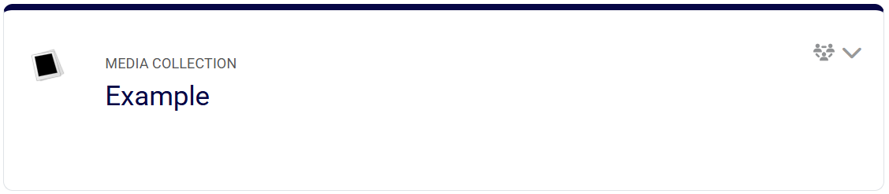
- Select the '+Add a Gallery' option.
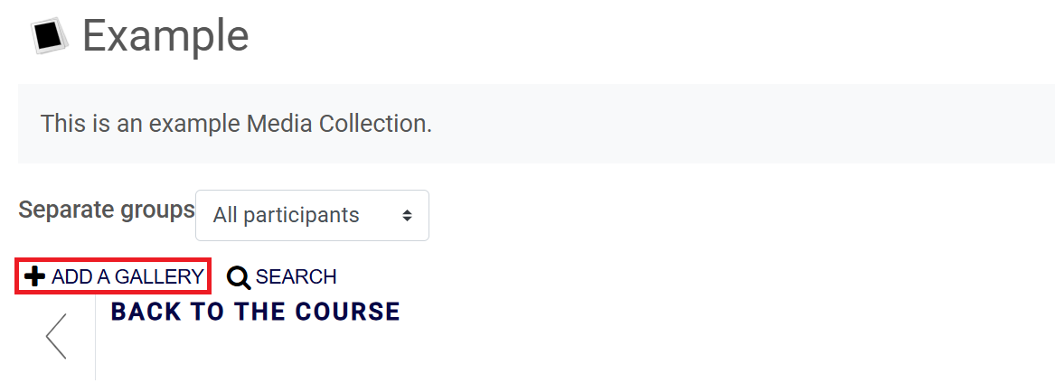
- Title your gallery with an appropriate name, unless the activity requests a specific title and click 'Save Changes'.
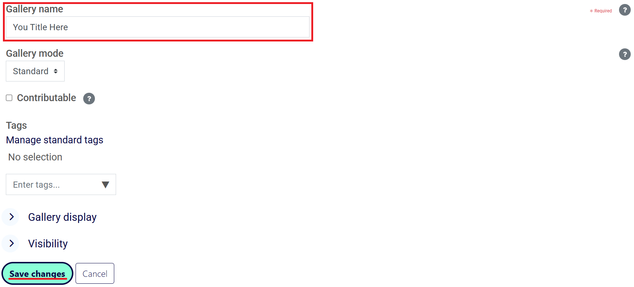
- Your gallery is now created, but it is empty, so the next step is to add your files. Select the '+Add an Item' option. Again, you will be given the option to title your file and add a description, please ensure this is something your tutor will recognise.
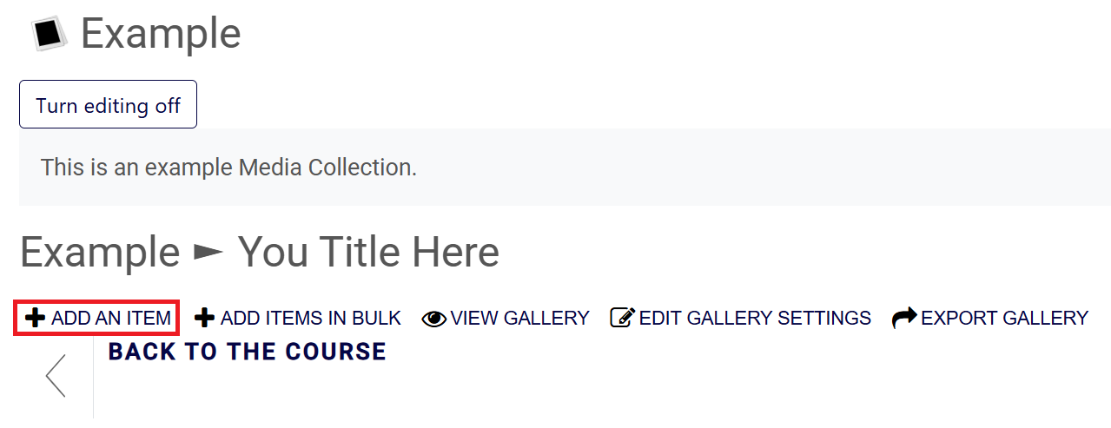
- Select the 'Choose a File' button to upload the file as and item and click 'Save Changes' at the bottom (no other options need to be selected or changed). Once this is complete, the upload will show in your gallery.
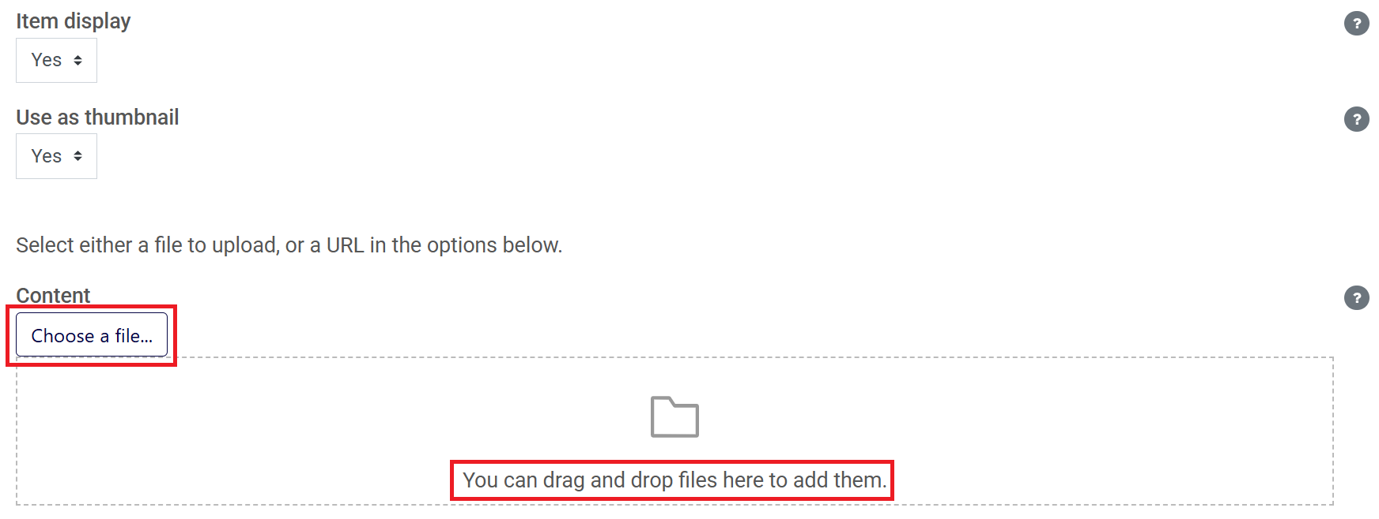
- Returning to the 'Media Collection', you should be able to see your gallery alongside other submissions and examples. This is where your tutor and / or your peers will be able to access your work. If you wish to make further edits, you will need to select the 'Turn Editing On' button first.

