OCA Learn

How can I find course resources on OCA Learn?

Resources Section
The majority of courses on OCA Learn are formatted to include a 'Resources' section that can be accessed via the 'Contents' menu located on the left of each course page, as shown in the example screenshot below.
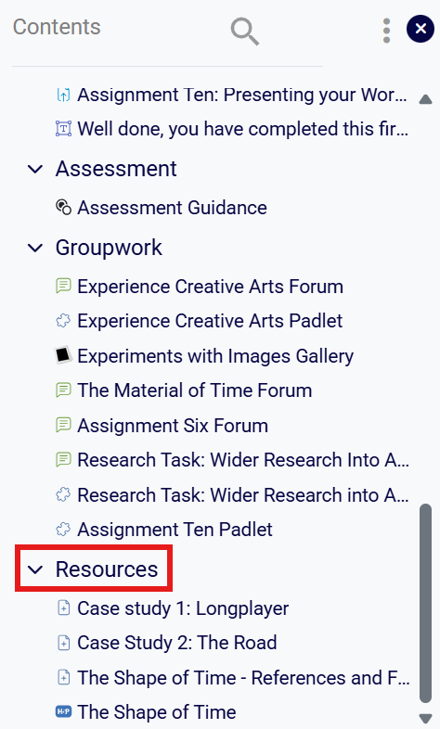
Course specific resources will be available within this section, along with the Reading List for your unit, as shown below.
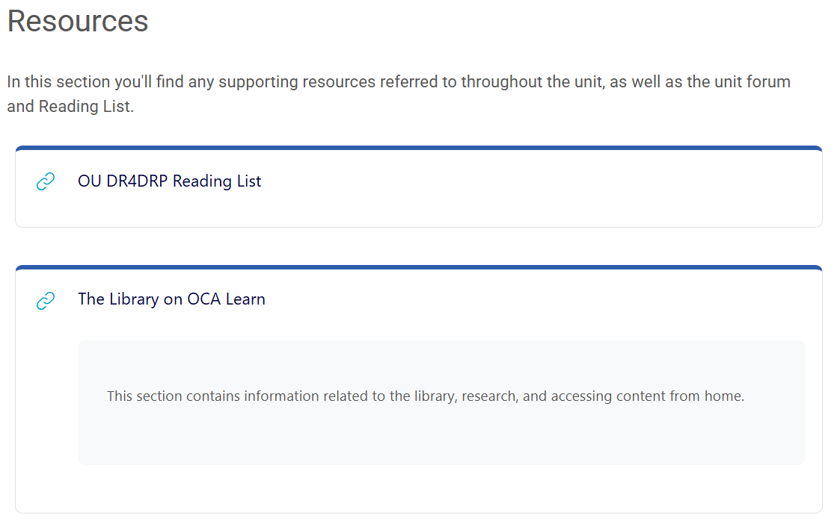
You may also be directed to access your Department Space to view resources; generally these are resources that can be applied across multiple units. Your Department Space can be accessed via your 'My Courses' page.

Missing Resources and Broken Links
If a resource that has been referenced or linked within your course material is no longer available or directs to the wrong web page, please ensure you check the 'Resources' section of your course for an updated version. If the resource refers to a web page, video or other format, please contact the TEL Team by submitting a support request or emailing techsupport@oca.ac.uk.
If you are unable to find a book, article, journal or any resource that should be available from the OCA Library or Open University Library, please email the OCA Librarian at library@oca.ac.uk for assistance.

