OCA Learn

What do the progress trackers mean on my course page?
Important Note: Progress displayed on OCA Learn isn't monitored and is not a requirement for course completion; progress trackers are for your own use only. The only requirement for your course being marked as 'Complete' is the submission of assignments and confirmation of feedback from your tutor.
If you have finished your course and all activity completion criteria has been met, but your course isn't displaying 100% completion, see the Why doesn’t my course show 100% completion? article for more information.
Completion criteria is generally only applied to end of Project activities, such as, Assignments, Feedback Points or Tutorials.
To determine the action(s) required for an activity to be marked as complete, you can select the 'Completion' dropdown button for further details, as shown in the example Assignment below.
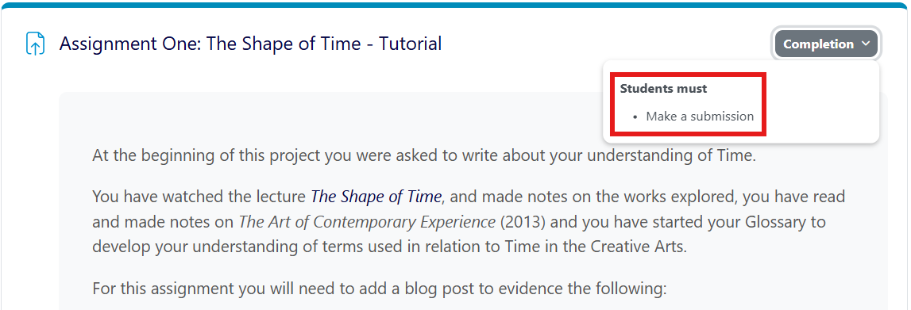
You can also view the completion criteria by selecting the activity and finding the labels located underneath the title, as shown in the example Assignment below.
