OCA Learn

How can I download my course materials in an alternative format?
Important Note: Following an update to OCA Learn, the Alternative File Format Conversion Tool is temporarily unavailable. The TEL Team will try to ensure this is reinstated as soon as possible. In the meantime, please use the Self Service Accessibility File Conversion, or select 'Print book' (as shown below) to download course content as alternatives.
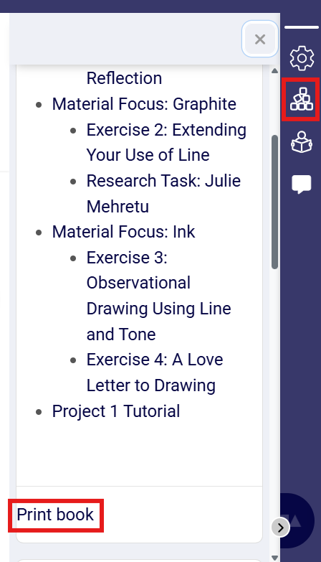

Alternative File Format Conversion Tool
OCA Learn offers alternative versions of course materials that can be downloaded directly using the Alternative File Format Conversion Tool provided through the Brickfield Toolkit; this tool gives you the ability to generate multiple alternate file formats for existing educational resources.
Where the Alternative File Format Conversion Tool is available, you will see the conversion icon as shown in the screenshot below.
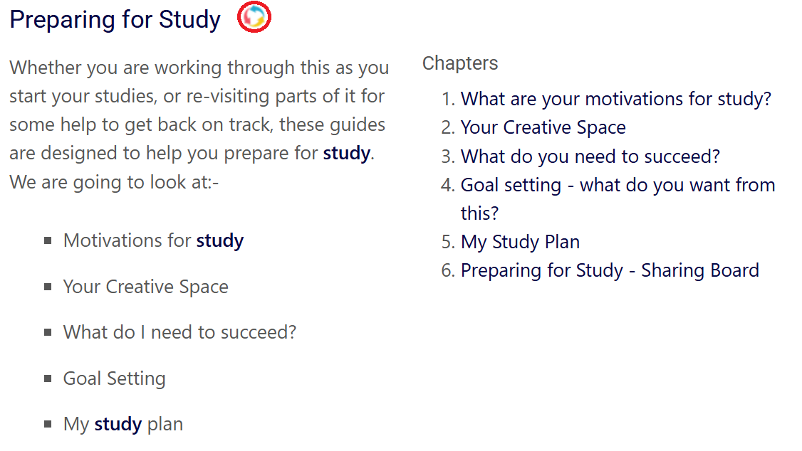

Upon selecting the conversion icon, a pop-up window will appear to enable you to select from the available format options, as shown in the screenshot below.
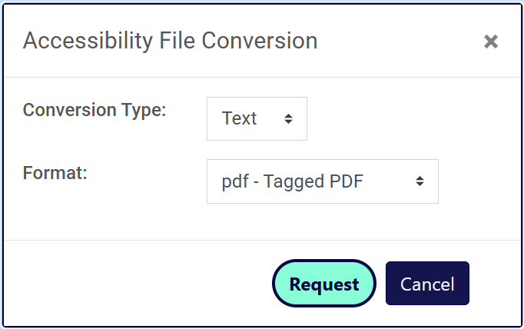

File Conversion Types
The 'Conversion Type' dropdown shows the available options for the resource you wish to convert, using the example presented above, you can convert a Book Activity to the following formats:
- Text
- Audio
- eBook
- Braille.
The main conversion types are then split into further formats, for example, selecting 'Text' will enable you to choose from the following options:
- PDF - Tagged PDF
- TXT - Plain Text
- HTM - HTML
- DOCX - Microsoft Word.
Each conversion type offers a range of different formats, so you can select the most suitable one for your needs and compatible tools you have access to.

Requesting a File Conversion
When you have chosen your preferred conversion type and format options, select the 'Request' button to proceed with generating the conversion. Upon selecting 'Request', the toolkit will check if the format conversion has already been requested and processed for the specific resource. If the conversion has already been processed, the alternative file will be stored and can be provided as an instant download.
If the file hasn't already been converted, you will see a confirmation message that reads 'Content retrieval in progress. You will be notified when the file is available'. This means that your request has been queued and you can return the course page by exiting out of the pop-up window by selecting 'X' or 'Close'.
Depending on the size and format of the resource being converted, your request may take from a few minutes to an hour. Once the conversion is finished, you will receive a notification alert on OCA Learn confirming the status of the conversion, as shown in the screenshot below, in addition to an email notification.
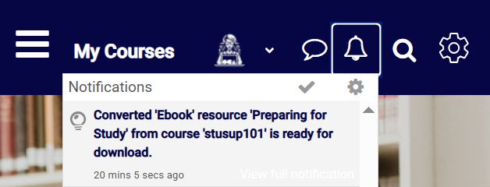
When you click on this notification, you will be able to open or download the file in your chosen conversion type and format.

