OCA Learn

How do I sign into OCA Learn (VLE)?
Before signing into OCA Learn, you will first need to ensure that you are signed into your OCA Email Account. For detailed guidance, see the How do I sign into my OCA Email Account? article.
- Navigate to OCA Learn - learn.oca.ac.uk.
- Select 'Log in' located in the upper-right corner.
- Select 'OCA Email Account through Google', as shown in the screenshot below.
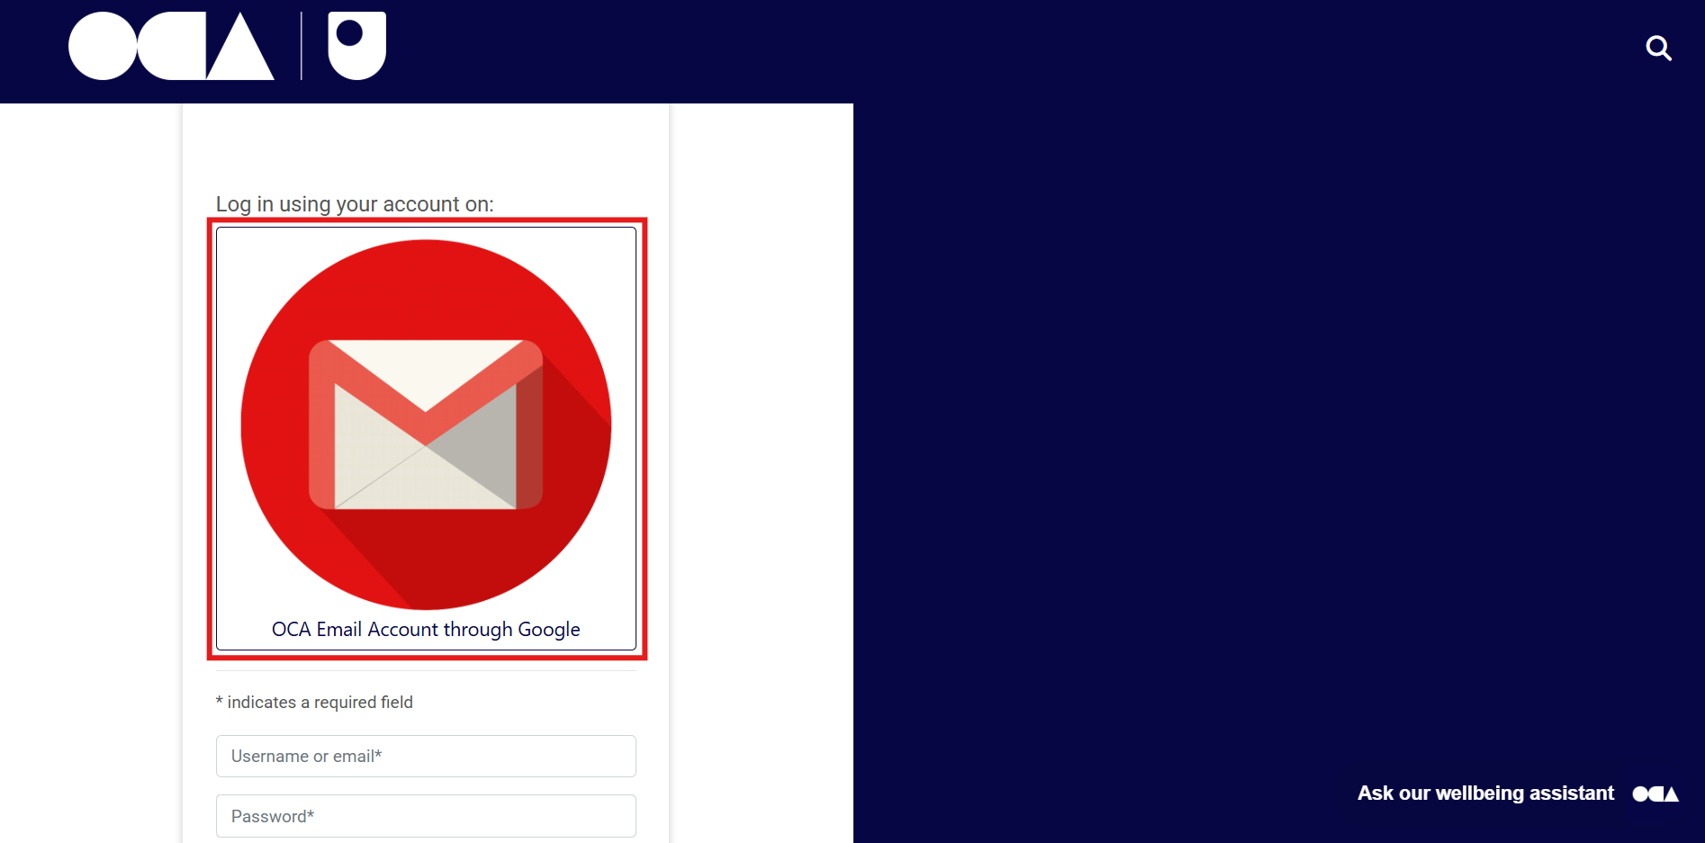
- If you are correctly signed into your OCA Email Account, you will be signed in without the need to enter a username or password.

If you are unable to sign in, please contact the TEL Team by submitting a support request or emailing techsupport@oca.ac.uk, providing a screenshot of any error message where possible.
In the event that you are signed into multiple Google Accounts and aren't using separate Google Chrome Profiles, you will be prompted to select your OCA Email Account from a list of accounts that have previously signed in.
Provided that you are signed into your OCA Email Account before attempting to sign into OCA Learn, at no stage will you be required to enter a username or password.

