OCA Email Account

How can I navigate the Google Homepage Interface?
The following screenshots demonstrate the Google homepage interface - google.com.

Sign In
Selecting the 'Sign in' button will enable you to enter your OCA email address and password to access your OCA Email Account.
Please see the How do I sign into my OCA Email Account? article for more detailed guidance.
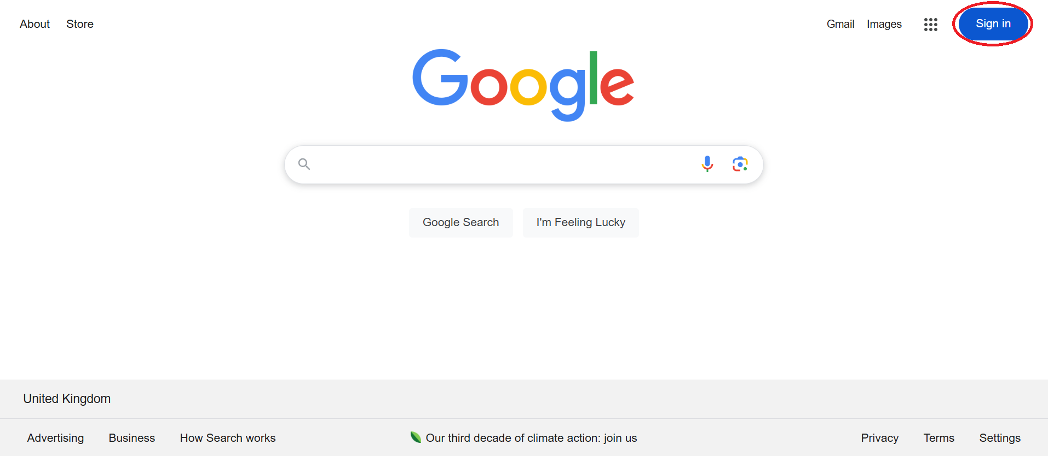

Once signed in, the 'Sign in' button is replaced by your Google Account Profile Icon (by default this is a circle containing the first letter of your name).
Selecting the profile icon will display information regarding the active Google Account and reveal the 'Manage your Google Account' option, from which you can access your account settings. Also available is the 'Add another account' option, which allows users to sign in with another account.
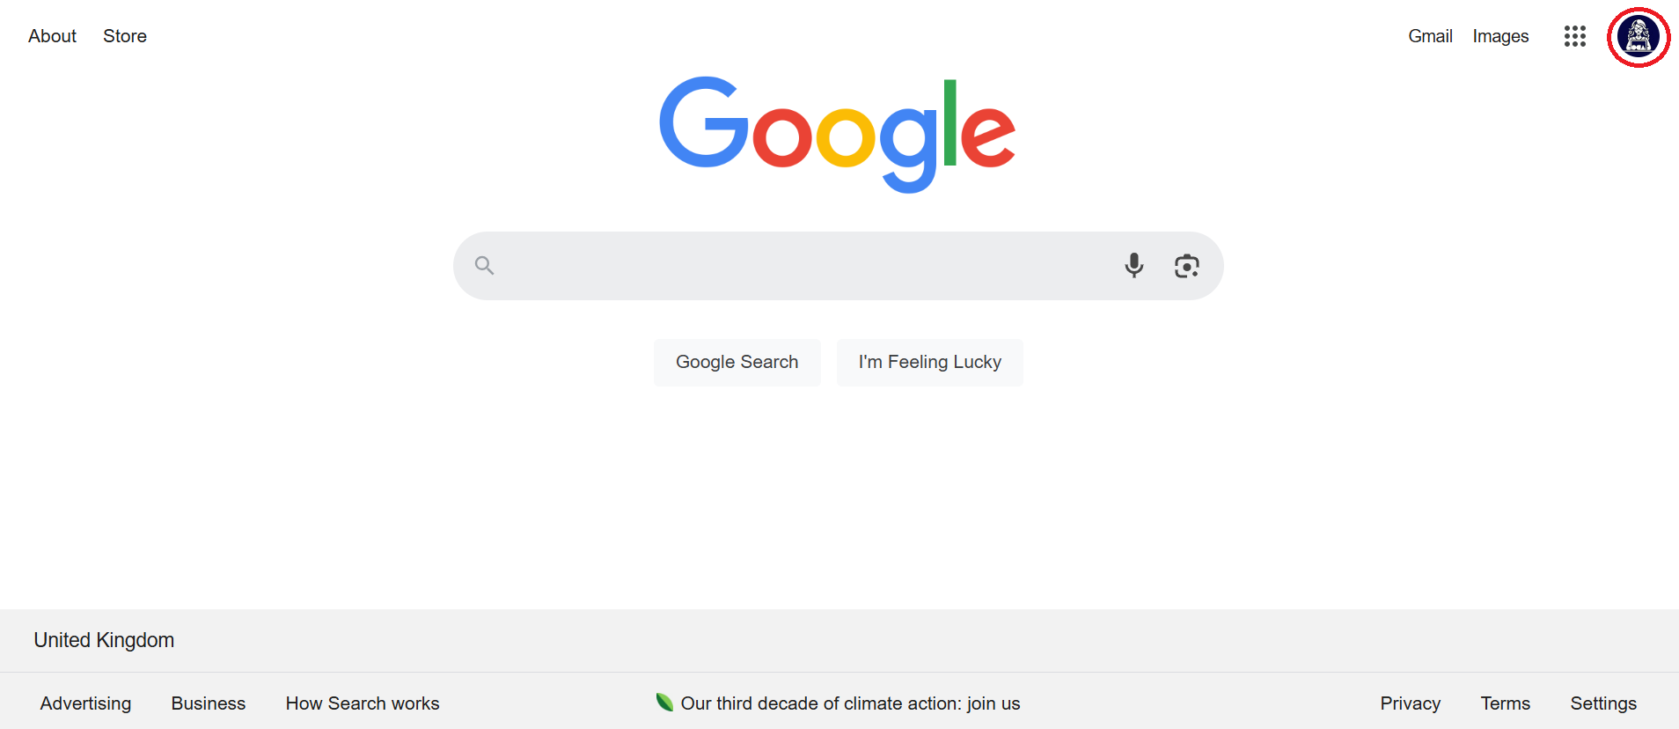

Google Applications Menu
The Google Applications Menu can be accessed via the 9 dot grid icon - note that this icon is available when viewing any Google page.
From the applications menu, you will find shortcuts to Google applications, such as Gmail, Drive and Meet. When signed into your OCA Email Account, you will also find shortcuts to OCA managed and recommended websites, including OCA Learn and OCA Spaces.
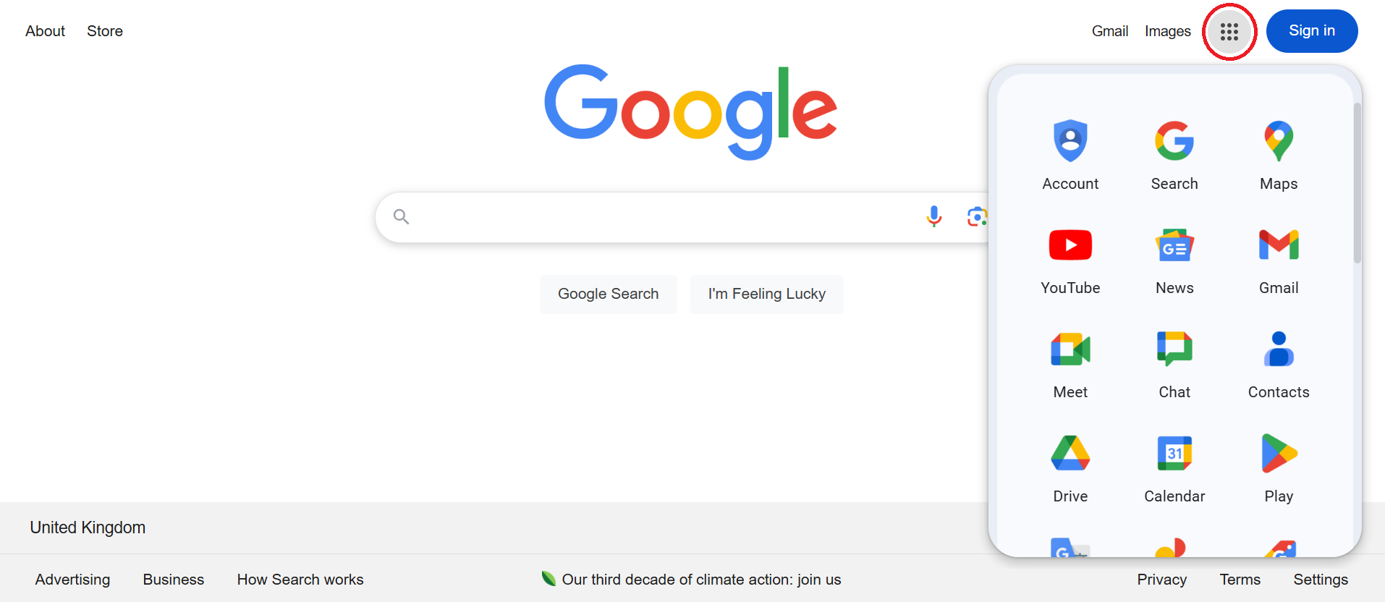

Gmail
The Gmail link is available in the upper-right corner of the Google homepage - google.com. Accessing this link will direct you to your student emails, from which you can read and reply to emails, send new emails and manage your inbox.
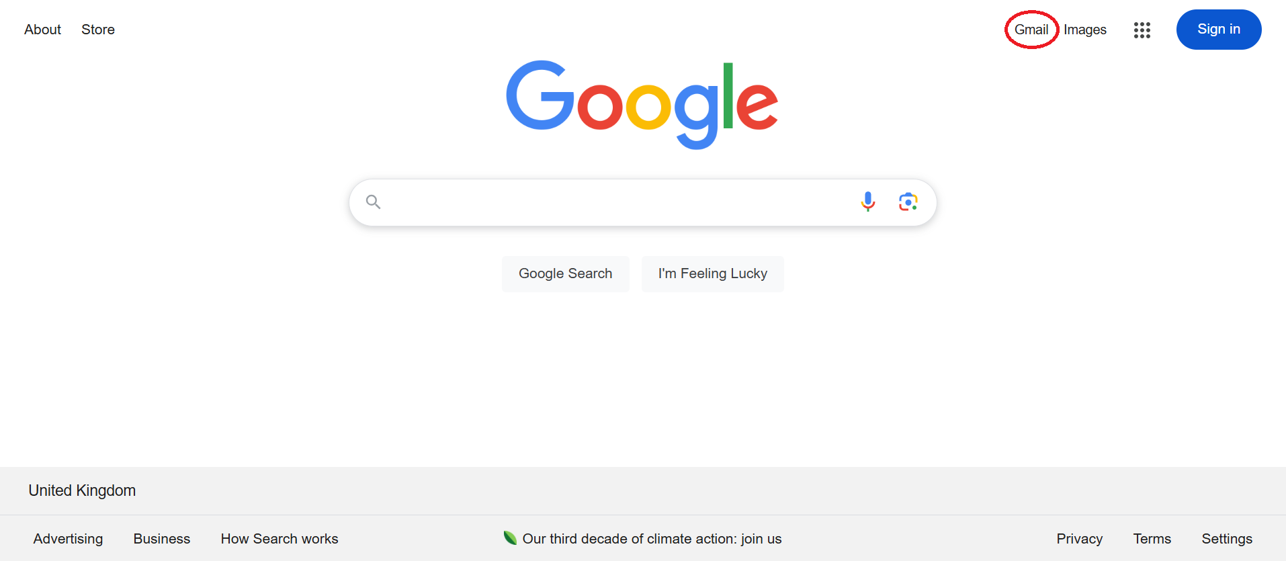

When viewing any Google page, you can also access the Gmail shortcut from the Google Applications Menu.
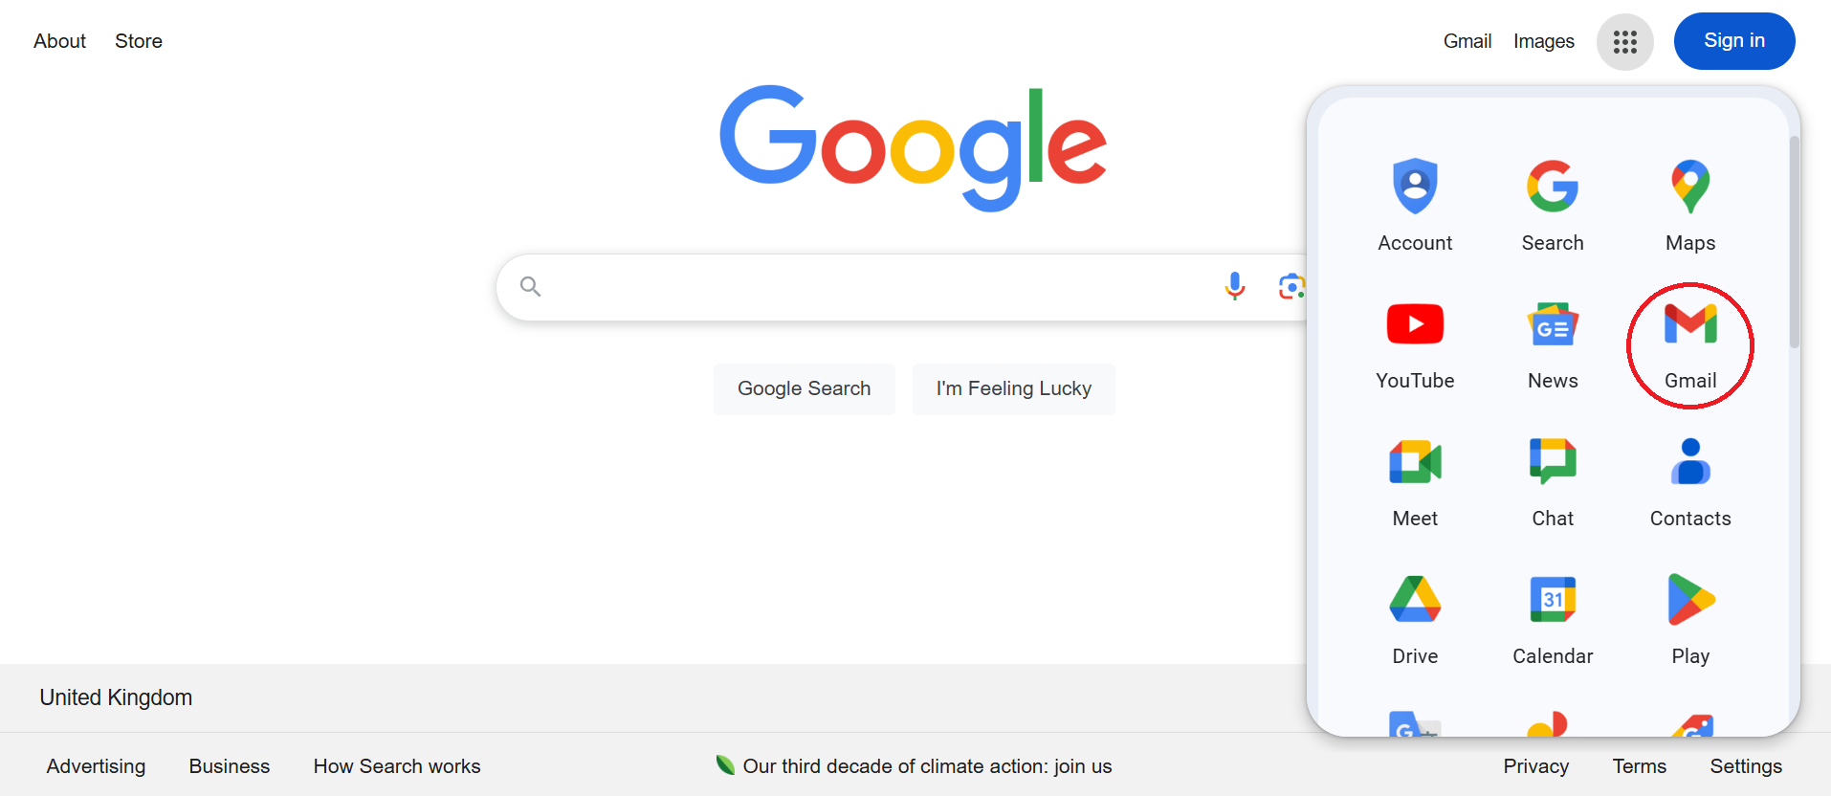
For more information, consult the How can I access my student email account (Gmail) and send emails? article.

