New to OCA? Start Here!

3. Before You Start - OCA Email Account
Before jumping into your course and getting creative, first take a moment to ensure that you are signed into your OCA Email Account. Your OCA Email Account is a managed Google Account and the key to accessing all OCA provided websites.
At OCA we use single sign-on (SSO) authentication - this means that you can sign into all of our sites using Google, without the need to enter any additional usernames or passwords.

Signing In
To sign in, navigate to the Google homepage - google.com - and select the blue ‘Sign in’ button located at the top-right of the page. You can then enter your OCA email address and password when prompted.
Your OCA email address will always follow the format 'name123456@oca.ac.uk' - the 6 digits are your unique student number.
Note that you can find your password in the Welcome Email issued on your start date. Upon your first successful sign in, you will be prompted to change your password to something that is more memorable to you.
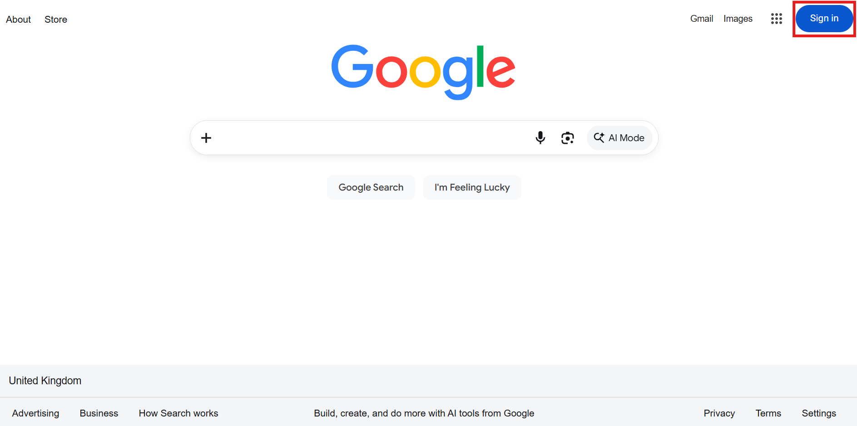
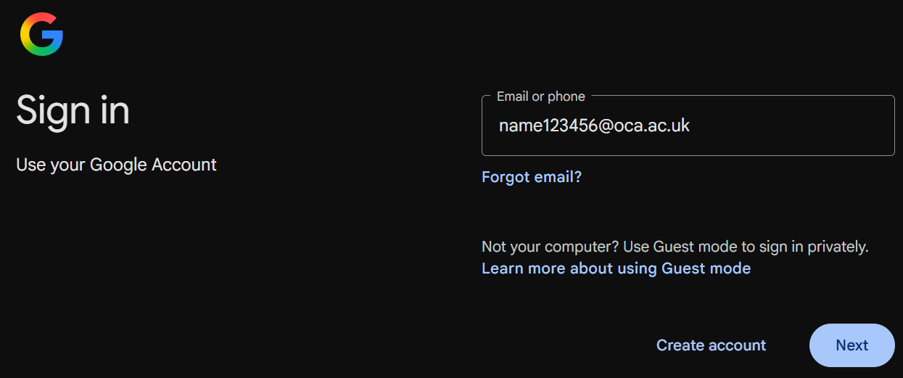
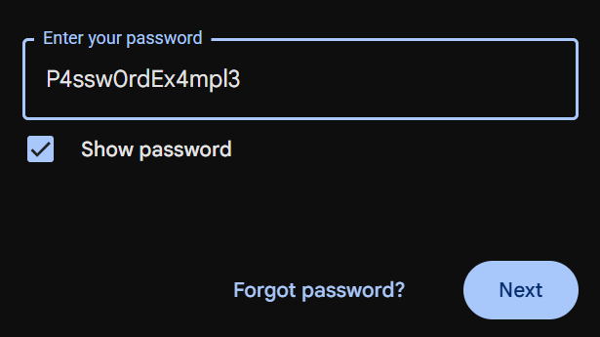

Ensure that you enter the password exactly as provided in your Welcome Email as your password is case sensitive (this means that lowercase and uppercase letters are treated as different characters, so ‘A’ isn’t interchangeable with ‘a’, for example).
For further step-by-step guidance and a downloadable guide, see the How do I sign into my OCA Email Account? article. If you are already signed in with a personal Google Account, consult the Existing Google Account section of the linked support page for more information.

2-Step Verification
If this is the first time you are signing into your OCA Email Account, you will have 30 days from your first successful sign in to set up 2-Step Verification. We have made 2-Step Verification mandatory to ensure that your account remains secure.
Failure to set up 2-Step Verification will result in temporarily losing access to your account as you won't meet OCA’s essential security requirements.
See the How do I enable 2-Step Verification (2FA)? article for a detailed explanation and guidance if you’re unsure.
Tech Top Tip: If you receive an error message that reads ‘Your sign-in settings don’t meet your organisation’s 2-Step Verification policy. Contact your admin for more info.’, it means that you haven’t successfully set up 2-Step Verification on your account.
You will need to request a 2-Step Verification exemption by contacting the IT Team - either by emailing ithelpdesk@oca.ac.uk, or 'Submit a request' via the Help Desk - this will enable you to regain access to your account.

Next Section | 4. Next Steps - OCA Learn and OCA Spaces →

