5. Further Sites and Tools
At this stage, you may feel more comfortable getting to grips with OCA Learn and OCA Spaces before exploring further sites and tools, so do feel free to come back to this section when you’re ready.
Your course content will direct you to various sites and applications, the most common of these are below. These tools will enable you to interact with your tutor and peers, access group work and enhance your research.

Padlet
As touched upon in the Basic Overview of OCA Systems section, Padlet (padlet.com/oca) is a tool that allows you to create virtual boards.
Potential uses for Padlet during your studies may include:
- Accessing resource and research hubs that have been created for your course and linked within course content, or via Department Spaces OCA Learn.
- Sharing work and feedback with peers via padlets that are linked within your course on OCA Learn.
- Creating your own padlet to collect research and aid in visualising your ideas to develop them to apply to your work.
- Creating your own padlet to document a process, trip, exhibition or experience.

Signing into Padlet
To sign into Padlet, you will need to ensure that you are accessing the correct log in page - padlet.com/oca. If you are already signed into your OCA Email Account, you can select the ‘Log in with Google’ option to be signed in without the need to enter a username or password. You will then need to select your OCA Email Account from those listed, followed by 'Continue' when prompted.
You will need to ensure that you follow this sign in process to be able to access existing OCA-managed padlets.

Creating a New Padlet
Once signed in, you can create a new padlet by selecting ‘+ Make’ at the top of the page and you will be guided through the ‘Make a padlet’ set up. To get started, you may wish to create a test board so you can try out all of the features and explore how you can use Padlet to complement your studies.
Please note that creating your own padlets isn’t a requirement for your course unless directed to do so, but you may be asked to add to existing padlets alongside your peers. Nevertheless, Padlet is a useful tool that can aid in the development of research, as well as sharing your ideas and coursework.
The ‘How can I use Padlet?’ article directs you to useful resources to learn how to use Padlet features.

Google Meet

Attending an Event
Both OCA staff and students are expected to utilise Google Meet (meet.google.com) to host tutorials, group work and events. Google Meet is a video conferencing service that works very similarly to Zoom, but is integrated with your OCA Email Account.
To attend a meeting, you will again need to follow the joining link that will be provided with the details of the session / event.
Tech Top Tip: You can access Google applications and services using the application tray. The application tray can be accessed from any Google page, for example google.com, and appears as an icon of 9 dots in a grid formation - see the screenshot below for clarity.
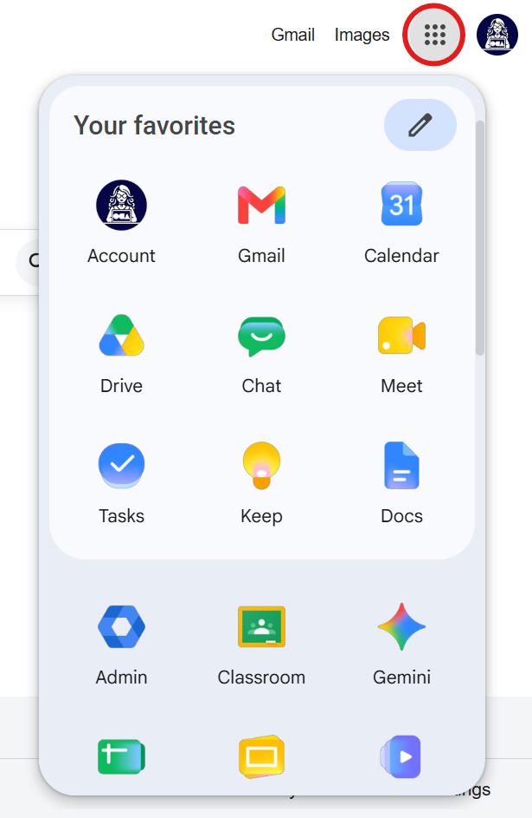
Scrolling down the list of applications, you will also find OCA shortcuts including links to OCA Learn, OCA Spaces, Microsoft Office and more.

Organising an Event
If you would like to organise your own peer session or event, you can use Google Meet. You can create events by adding them to your Google Calendar (calendar.google.com) - see the step-by-step guide below, or the ‘How can I create a Google Meet event?’ article.
- Select ‘Create’, followed by ‘Event’ and enter essential details such as title, date and time. You can use the ‘Add guests’ field to enter the email addresses of attendees and this will trigger an email invitation.
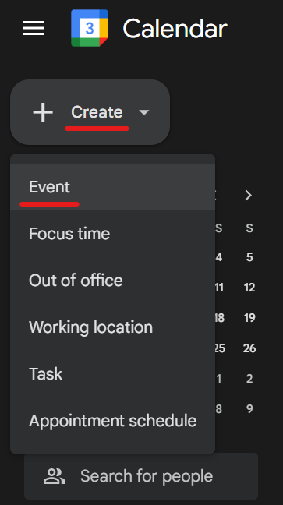
- Select ‘Add Google Meet video conferencing’ to generate a Google Meet session.

- To join your meeting as the host, you will need to open the event and select ‘Join with Google Meet’. Attendees will also use this button if you have invited them via email using ‘Add guests’, or you can share the unique joining link, as highlighted below.

Next Section | 6. Saving Your Work →

