How can I use the OCA Spaces editor to post my work?
To access the OCA Spaces editor - called the Gutenberg Editor - you will need to create a new post, or edit an existing post. For more information, see the How do I create a new post on my learning log? article.

The Gutenberg Editor, also known as the 'Block Editor', uses multimedia blocks to enable you to build your post. Each block type provides different capabilities and supports different media types, such as text, image and video and can be combined to create your post.
The screenshot below illustrates the content of a typical learning log post with notes on how it has been constructed using various block types. There are many more block types available to help you build your post to best present your work.
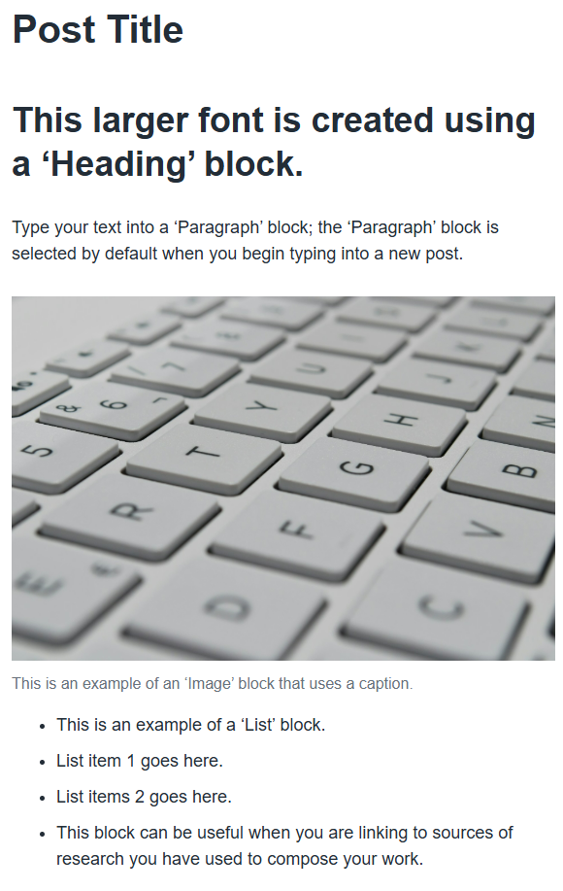
The guidance below describes the basics you will need to know in order to create posts on your learning log, but if you would like to explore more features, take a look at the WordPress 'Say Hello to Gutenberg, the WordPress Editor' Page. You can also find a variety of video tutorials on websites like YouTube, or text-based resources via searching online.

Inserting Blocks into a Post
1. After creating a new post, you will be presented with the editor interface and will see a settings / options menu located on the right, as shown in the screenshot below. If you can't see the menu on the right, select the icon circled in red in the screenshot below to reveal it.
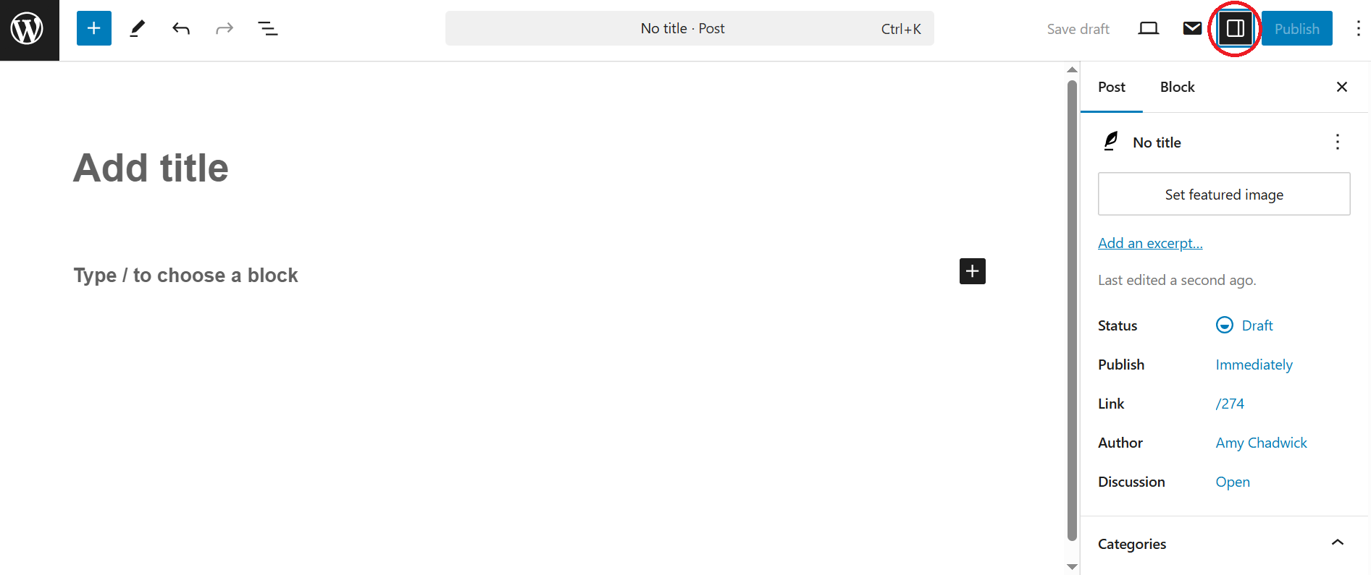
2. Enter your post title by replacing the 'Add title' text.
3. You can now begin typing in the default paragraph block, or select the plus (+) icon to select a different block type, as highlighted in the screenshot below. You can also select a block from the menu by selecting the blue plus (+) icon in the top left.
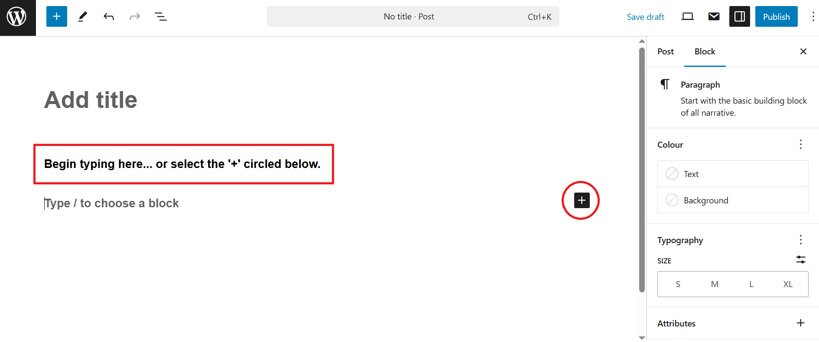

You can either select a common block type from the list, search for a specific block type, or select 'Browse All', as shown in the screenshot below.
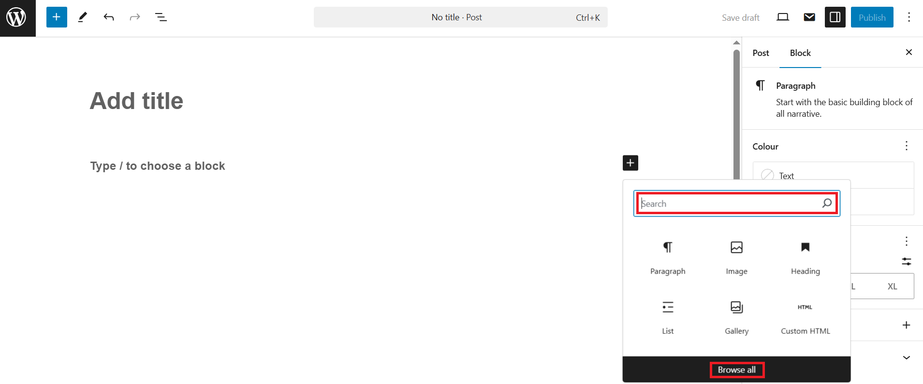

Hovering your cursor over a block type in the left-hand menu will show a pop-up that provides an example and explanation of how it can be used, as shown in the screenshot below.
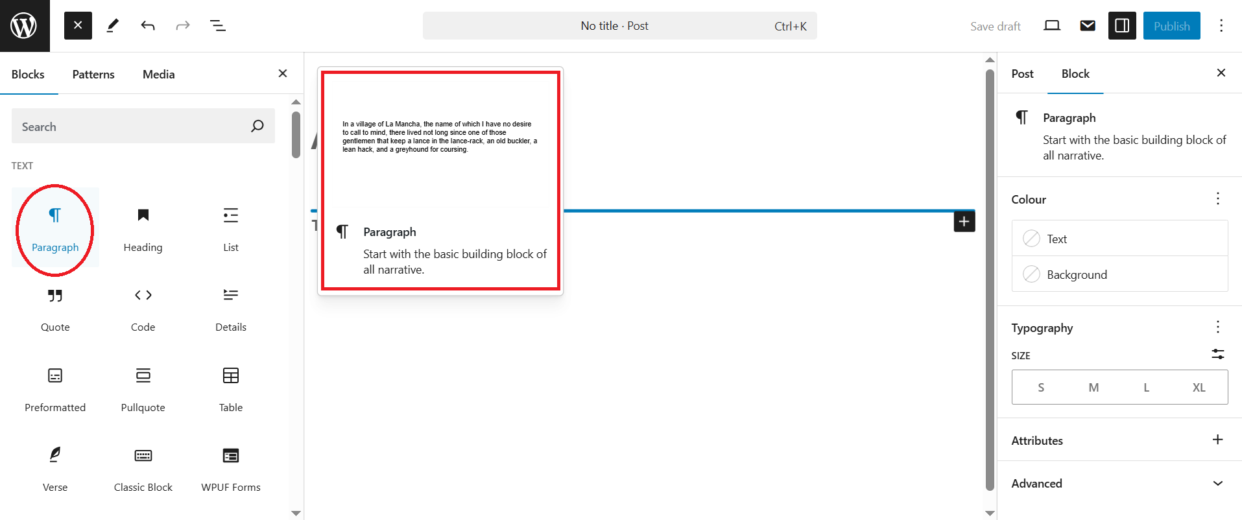

See the What do the different block types mean in the OCA Spaces editor? article for an explanation of the block types most relevant to posting your work, along with how to change, rearrange and delete them.

Block Settings
When you have inserted a new block or selected an existing block, you can edit settings via the 'Block' menu available on the right, as shown in the screenshot below. The menu denotes the block type you have selected, as well as the available editing options.
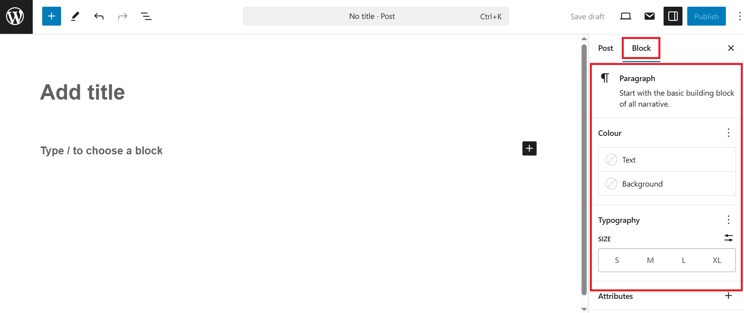
Try creating a test post on your learning log and use different block types to get an idea of how you can build your post to best present your work. Don't be afraid to edit the settings from the 'Block' menu to see how you can manipulate the appearance / functionality of a block.

Post Settings
Once you have constructed your post and are happy with how it appears in the editor, you can use the 'Post' menu available on the right to amend your post settings before publishing to your learning log. If the 'Block' menu is currently selected, click on 'Post' to open the menu, as shown in the screenshot below.
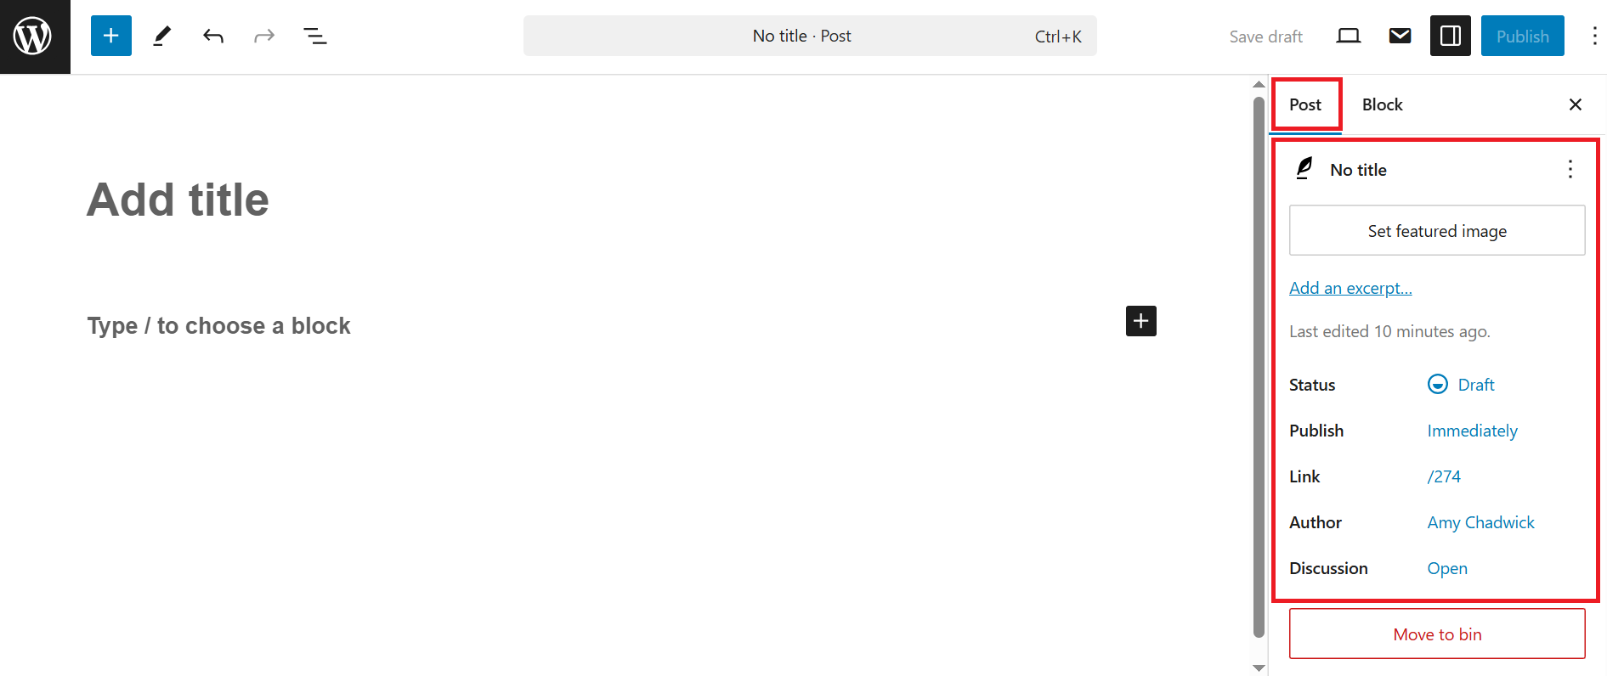

Before publishing your post, the following options can be amended:
- Set featured image - This option enables you to upload an image that will appear as the featured image for the post on your learning log homepage.

- Status - By selecting 'Status', you can choose the visibility option for your post with each option offering a short description below it.
Please note that selecting the blue 'Publish' option in the top right - outlined in the 'Publishing Your Post' section below - will enable you to select visibility before publishing instead of changing the 'Status' at this stage.
You must always select the 'Public' visibility option or your post won't be visible to anyone but yourself and OCA Spaces Administrators. If you would like your learning log to be private, see the How can I view and / or update my learning log privacy setting? article for more information.

- Link - This option enables you to edit the text that appears as the last part of the web address (URL). By default this will be the title of your post, for example - spaces.oca.ac.uk/yoursitenamehere/category/coursework/project-#/post-title. Changing the 'Link' will alter the '/post-title' section of the web address (URL); it is recommended to leave this as the default link.

- Categories - It is important to assign your post the relevant Project / Assignment category in order to keep your work organised and easy for your tutor to navigate. To select a category, simply place a tick in the box next to the category you wish your post to be visible under. For more information on categories, see the How can I organise posts / use categories on my learning log? article.

Publishing Your Post
Having successfully constructed and categorised your post, it is now ready to publish to your learning log. Follow the step-by-step guidance below to publish your post:
1. Select the blue 'Publish' button located in the top-right, as shown in the screenshot below.
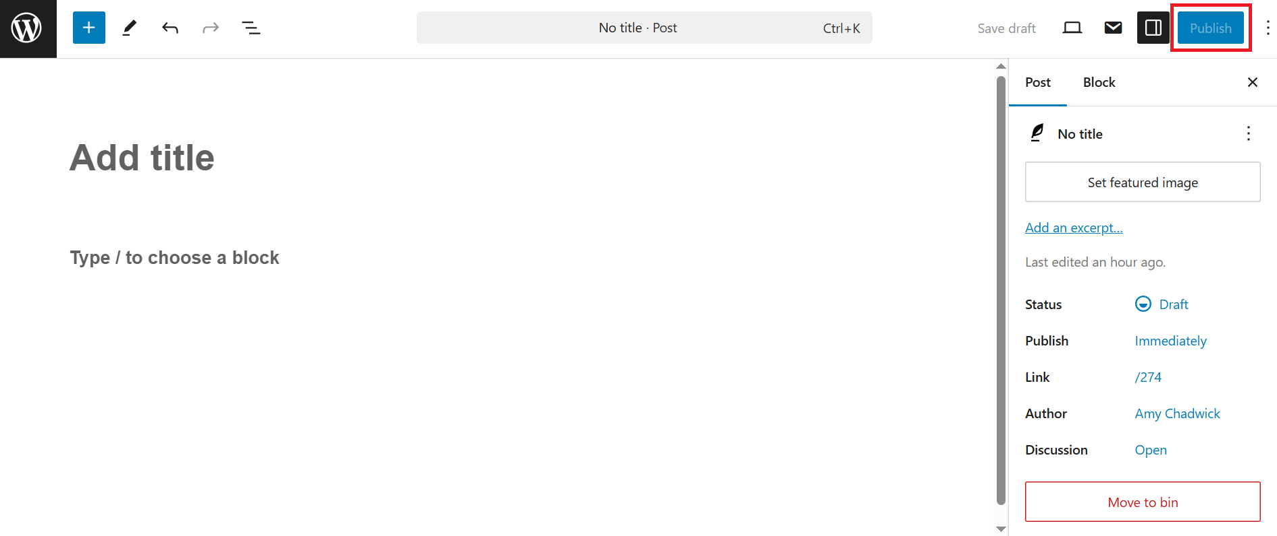
2. You will be presented with the 'Are you ready to publish?' menu from which you can edit the post settings before confirming.
3. Remember to leave the 'Visibility' option as the default 'Public' to ensure your post is accessible on your learning log.
4. By amending the 'Publish' option, you can choose to publish your post immediately or on a selected date / time.
5. If you haven't already assigned your post to a category, you can do so by selecting the 'Suggestion: Assign a category' option.
6. Select the blue 'Publish' button again to confirm. You should now see a confirmation message that reads 'Post Title is now live' and can select 'View Post' to see the post displayed on your learning log.

Useful Resources
- Support Guides, WordPress [online - articles covering all aspects of WordPress].
- Intro to Publishing with the Block Editor, WordPress [video - 39 minutes].
- Intro to the WordPress Block Directory, WordPress [video - 8 minutes].

