How can I post to a forum and insert images and / or links?

Creating a New Post
When viewing a forum activity on OCA Learn, you can create a new post by selecting 'Add discussion topic', as shown in the screenshot below.
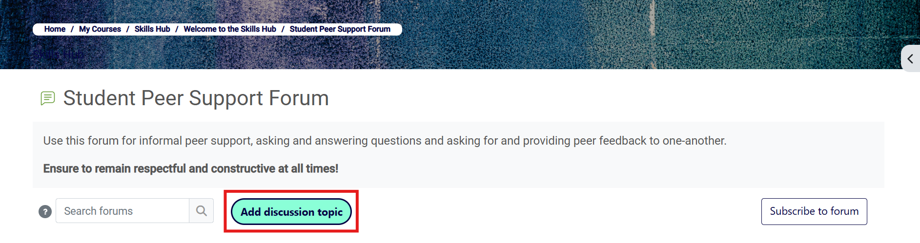
Please note that this option will create a new discussion thread, so if you are trying to respond to an existing discussion started by another user, see 'Replying to a Post' below.

Replying to a Post
To reply to a post, select the relevant discussion thread followed by the 'Reply' button located beneath the post and this will open the text editor as shown in the screenshot below.

To compose a simple text-based reply, type your text in the 'Write your reply...' field and select 'Post to forum' to submit.
If you are replying to a response that another student has contributed to a discussion, ensure you select the 'Reply' button directly beneath the post you are responding to; not only does this ensure the user receives a notification, but your response will be nested under the original post.

Using the Text Editor
To compose a more complex reply using text, images, links and so on, select the 'Advanced' option, as shown in the screenshot below, to access additional editing features.
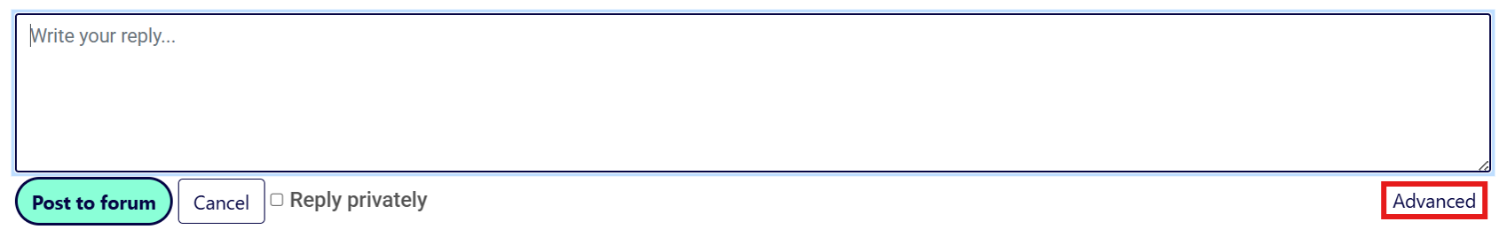
You will now be viewing the advanced text editor, as shown in the screenshot below.
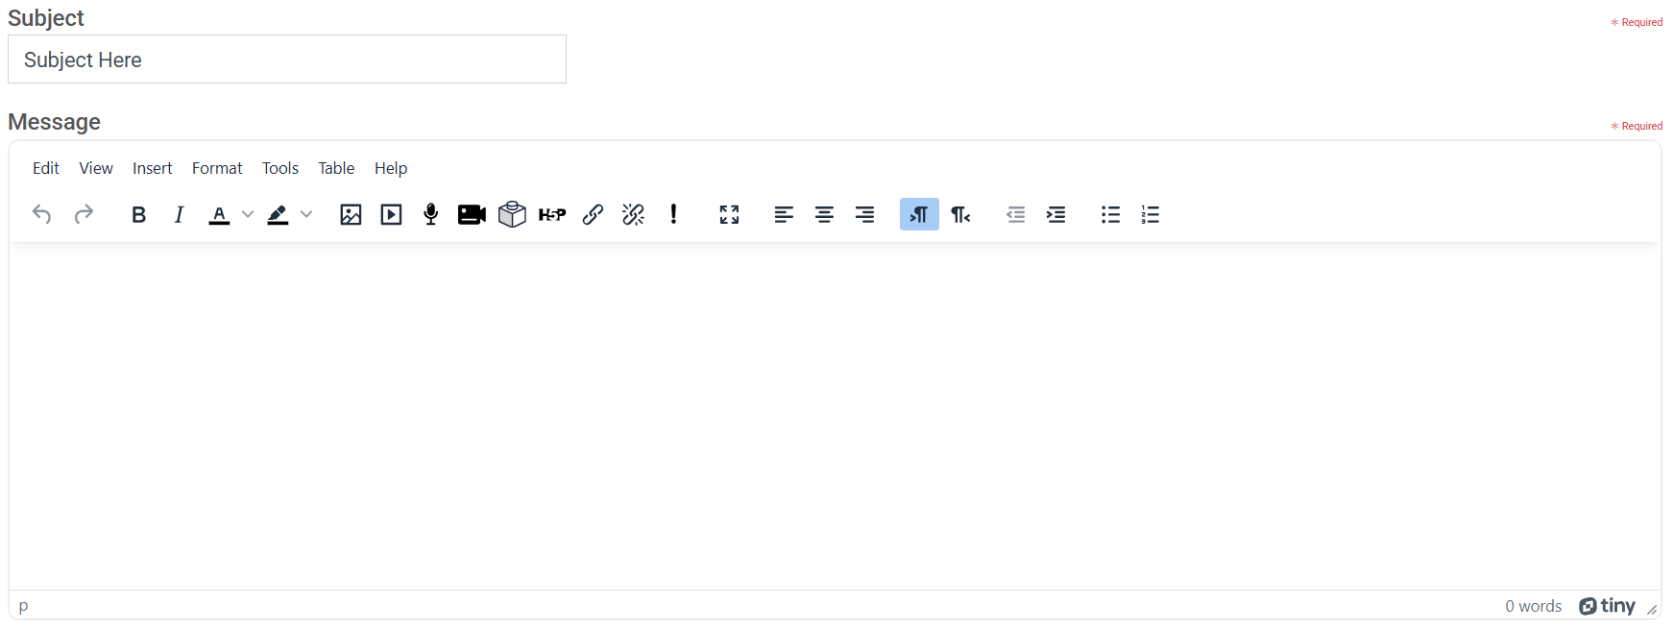
See the sections below for tips on inserting images and links to your post. Once you have finished composing and proofreading your post using the advanced text editor, scroll down and select the 'Post to forum' button to publish.

Inserting Images
To insert an image, you must be using the advanced text editor.
1. Select the 'Image' icon, as highlighted in the screenshot below.
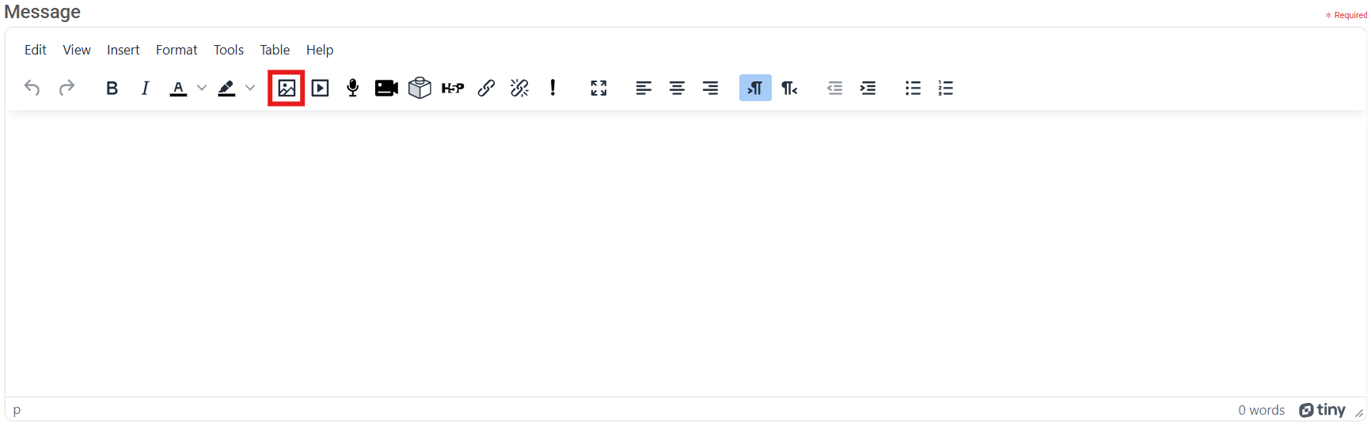
2. You can then upload your image(s) by clicking the area, or dragging and dropping your files into the large area highlighted in the screenshot below. You can also add images via a URL at the bottom of the pop-up window.
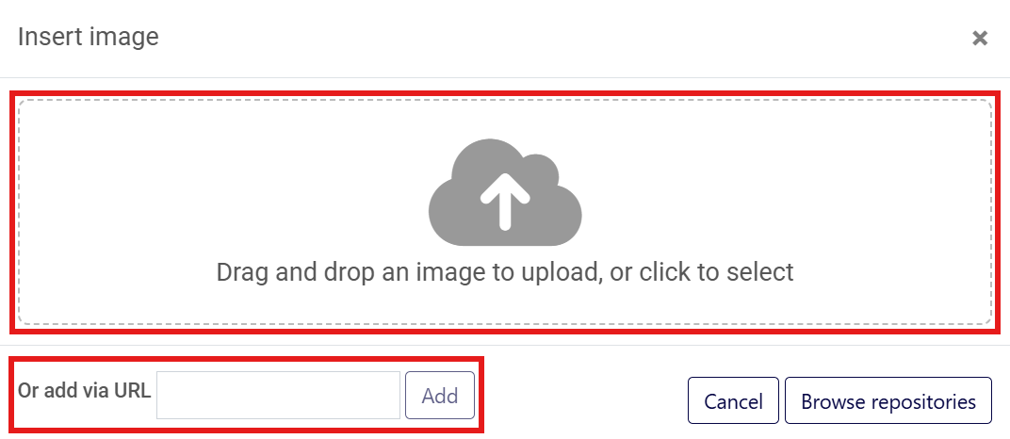
3. Once uploaded you will see the 'Image details' window. At this stage you can change the image size by selecting the 'Custom size' option.
Note that if your image is more than 1000 pixels wide, try reducing the width so it displays in your forum post as intended. Leaving 'Keep proportion' ticked will ensure that your image isn't incorrectly compressed or stretched.
4. You will now need to add a short description of the image, or tick 'This image is decorative only' before finishing with the 'Save' button.

Inserting Links
To insert a link, you must be using the advanced text editor.
1. Select the 'Link' icon, as highlighted in the screenshot below.
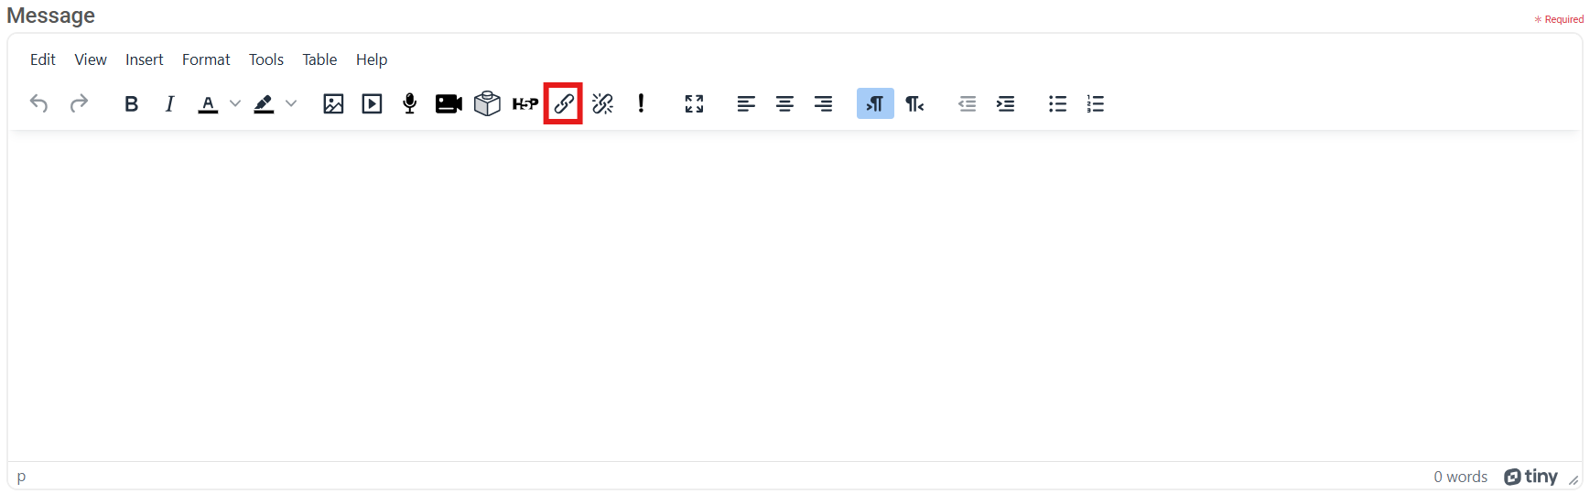
2. Type the text you would like to appear as your hyperlink in the 'Text to display' field. For example, this could be the name of the site or title of the article / resource you are linking to.
3. Copy the URL of the site you would like to create a link to; this can be found in the address bar at the top of your web browser. Paste the URL of the site into the 'Enter a URL' field.
4. Finish by selecting the 'Create link' text to insert the link into your forum post.

