4. Next Steps - OCA Learn and OCA Spaces

OCA Learn
Now you are signed into your OCA Email Account, you can access your Induction. Navigate to OCA Learn - learn.oca.ac.uk - and select the ‘Log in’ button located at the top-right of the page. Selecting the ‘OCA Email Account through Google’ option, as previewed below, will sign you in automatically.
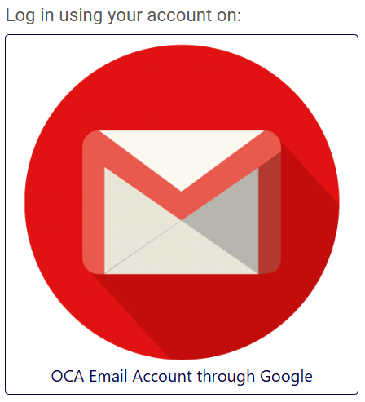
Remember, there is no need to enter a username or password when you are already signed into your OCA Email Account.
OCA Learn acts as the hub for your online studies where you will find your course, department space and information repositories, all available by selecting ‘My Courses’ located on the navigation bar at the top of the page.
Please note that you will only be able to access the OCA Induction course(s) until your 2-week induction period has ended.

Tech Top Tip: On the navigation bar at the top of OCA Learn, you may have noticed an icon that looks like 3 horizontal lines, as highlighted in the screenshots below. This is referred to as the 'hamburger' menu and selecting the icon will open a shortcut menu where you can find links to various OCA applications and core resources.
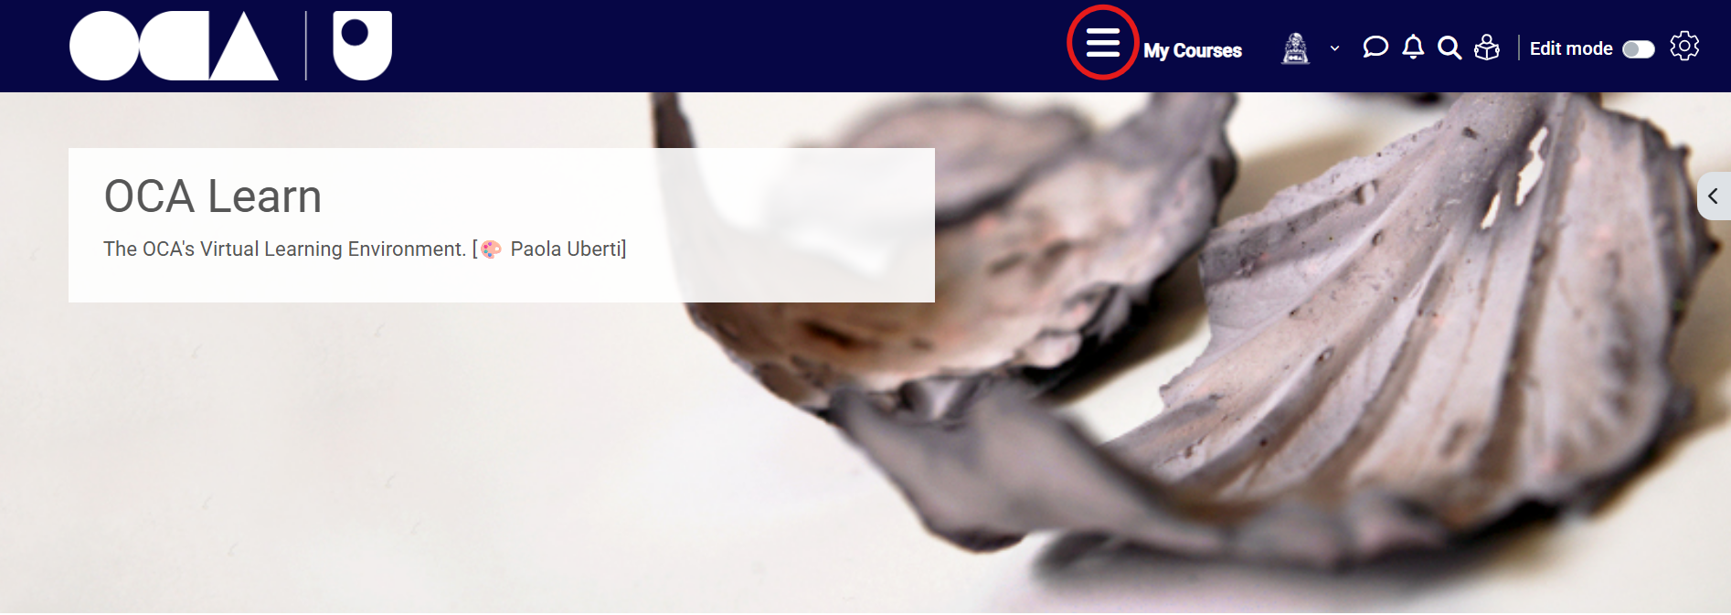
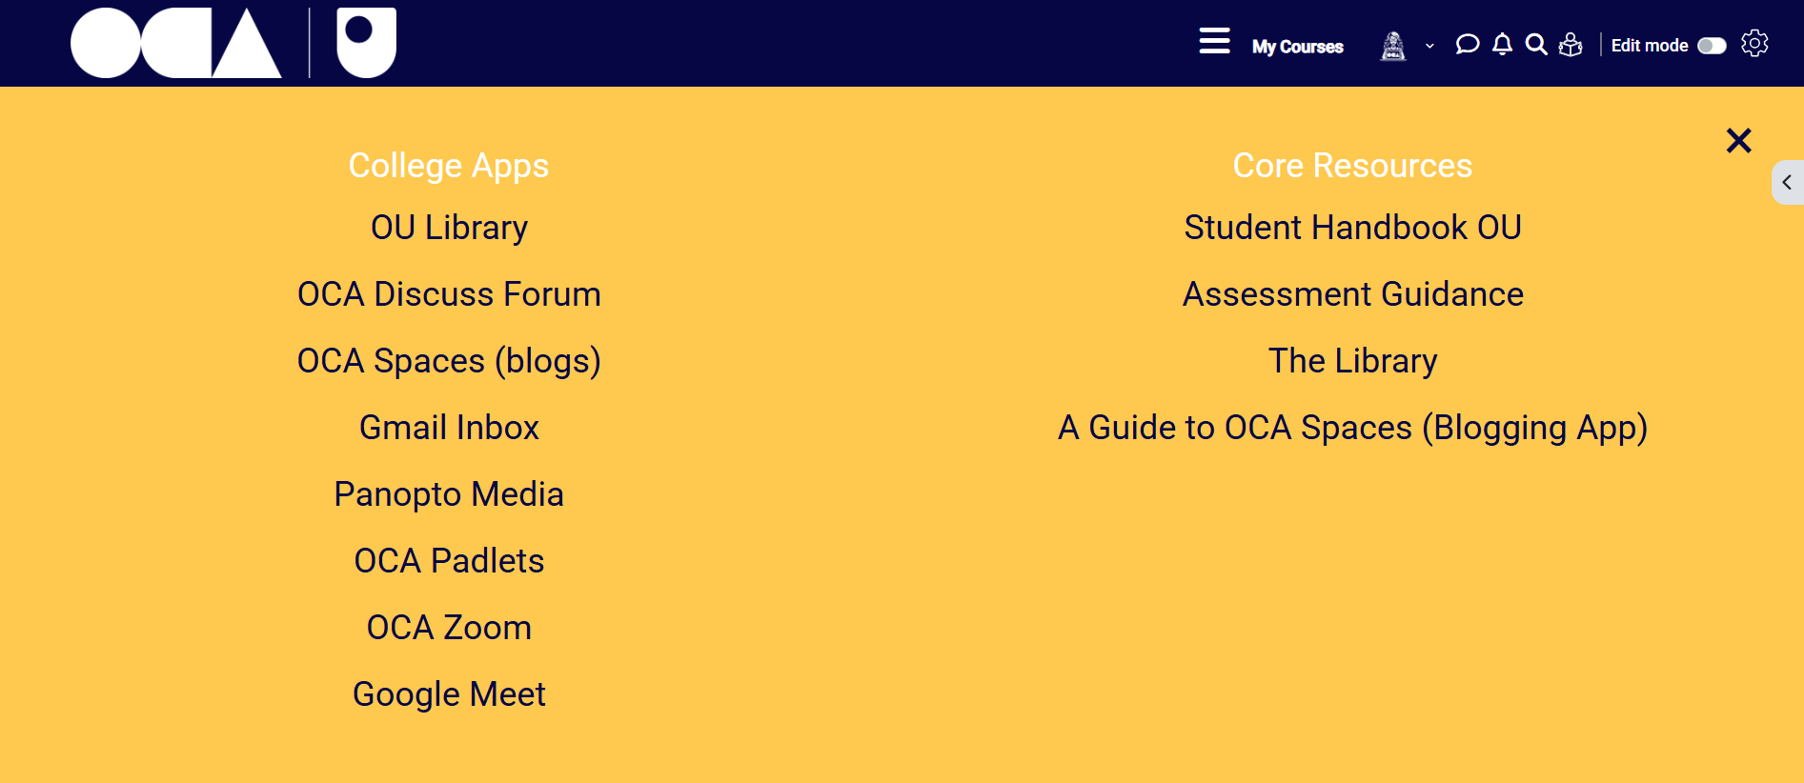

OCA Spaces
Once you are more familiar with OCA Learn from exploring your Induction course(s), you may wish to make a start on your learning log so you will have somewhere to post your work; this is where OCA Spaces comes in.
OCA Spaces can be used to create your own ‘learning log’ to house all of your exercises, assignments and research, but what is a learning log? In simple terms, a learning log is used in the same way an online blog would be. You can create posts that contain text, images, videos, links and more to showcase your work. You will create a new learning log for each unit that you study to keep a chronological ‘log’ of all the work that you complete towards your course.

To set up your first learning log, sign into OCA Spaces - spaces.oca.ac.uk - by selecting the blue ‘Sign in with OCA email’ button, as with OCA Learn, you will be automatically signed in.
You can now create your learning log by selecting ‘Add a Site’, as highlighted in the screenshot below.
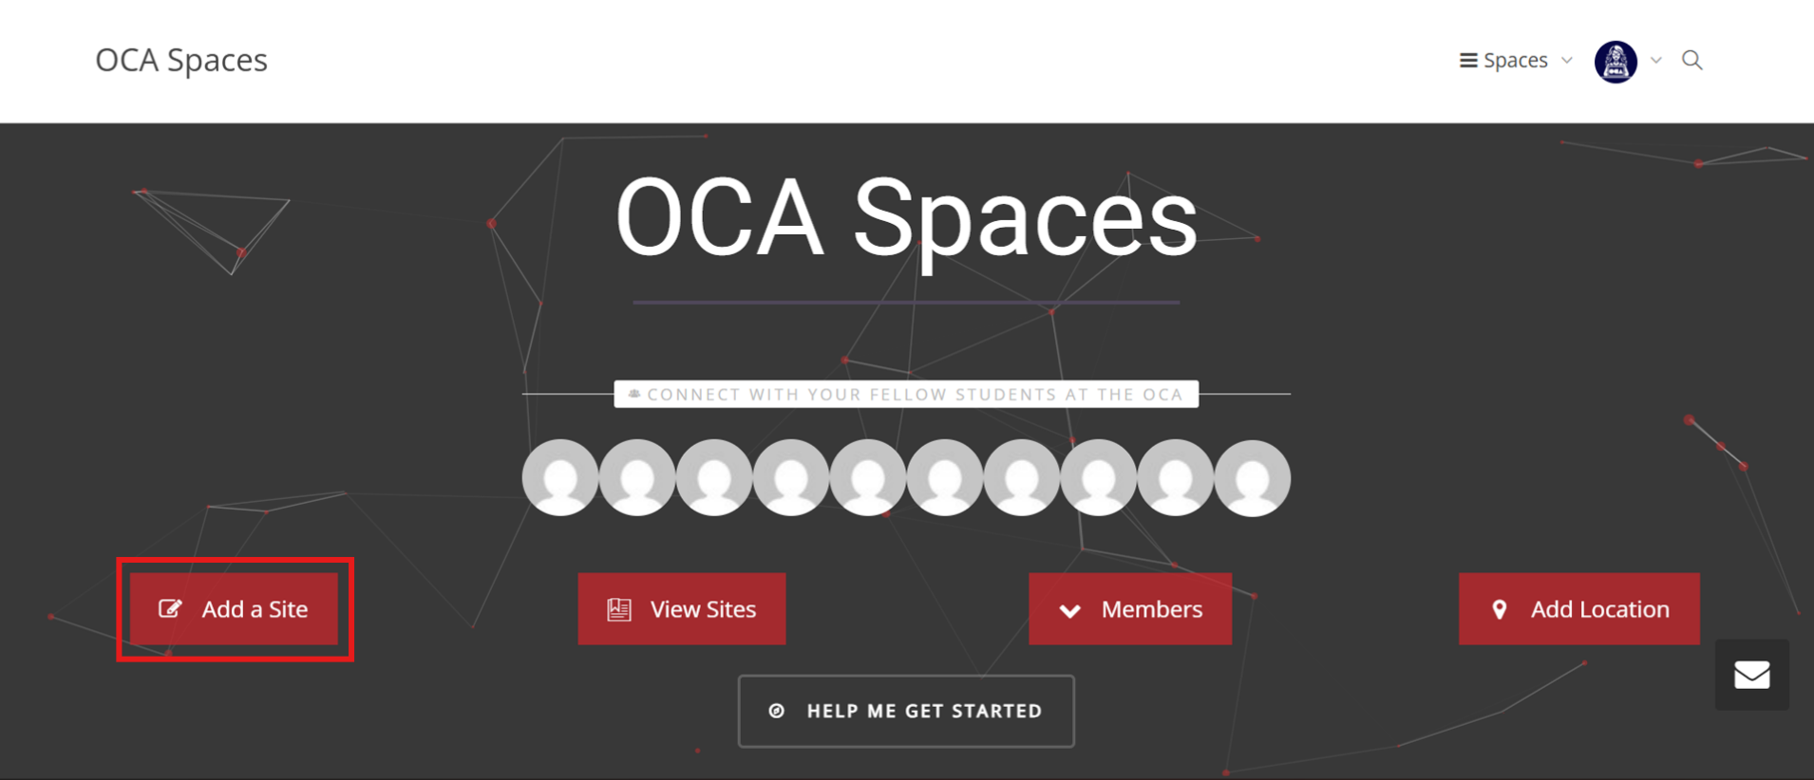
See the How do I create a learning log using OCA Spaces? article for a full step-by-step guide on completing the 'Create a Site' form to generate your new learning log.

Once your learning log has been set up, you can start getting to grips with navigating the OCA Spaces interface. The support pages linked below should help you begin.
If you are feeling overwhelmed or unsure at this stage, please feel free to create a test post on your learning log and give it a go to become familiar with the process; you may even wish to create another learning log for testing purposes that won't be viewed by your tutor or peers.
- How can I navigate the OCA Spaces Interface?
- How do I create a new post on my learning log?
- How can I use the OCA Spaces editor to post my work?
- How can I organise posts / use categories on my learning log?

Next Section | 5. Further Sites and Tools →

